QUAKER QUILL
QUAKERTOWN BUSINESS& PROFESSIONALWOMEN’S CLUB
P.O. BOX 2, SPINNERSTOWN, PA 18968

STATE THEME: CELEBRATING 100 YEARS OF WOMEN HELPING WOMEN WITH PASSION AND PURPOSE
DISTRICT: BE KIND

www.bpwpa.wildapricot.org www.bpwfoundation.org www.BPWQuakertown.org
www.facebookcom/bpwquakertown BPWQuakertown@gmail.com

OFFICERS 2018-2019
President –Rita Woodward Corresponding Secretary – Gladys Benner
Vice-Presidents – Sue Lewis and Linda Lokay Treasurer – Gail Jancsics & Crystal Smith
Recording Secretary – Ellen Miron &Nancy Werner Parliamentarian – Judy Guise

Volume 66 Issue 5 February 2019

NOTE: RESERVATION CONTACT HAS BEEN CHANGED FOR THIS MEETING
February Meeting
Date – February 26
Place – – Arts & Entertainment Center, McCoole’s Restaurant, Quakertown
Time – 5:30 Networking, 5:50 Business Meeting, 6:15 Dinner, 7:15
Menu – Spring Mix with Grilled Salmon or Chicken Marsala. Also included is pita with humus, soup, and coffee or tea. Dessert provided by Lyn Treffinger and Nancy Werner.
Cost - $27
Program –Bring something that makes you happy, to share with your friends. It can be a photo, a story, poem etc. Tell us what makes your heart "Happy".
.You can make your reservation by calling Ellen Miron – 215-538-2457 or email ellen_miron@verizon.net RESERVATIONS OR CANCELLATIONS SHOULD BE MADE NO LATER THAN 4:00 pm ON FEBRUARY 22. PLEASE NOTE: after you reserve if you are unable to attend the meeting, you are responsible for the meal payment.

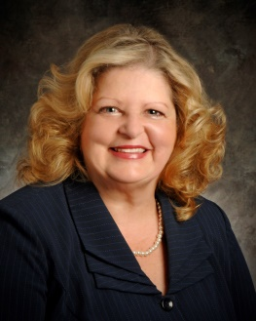
President’s Message
What a February 2019 it has been... Minus 7 to 60 degrees, I am really looking forward to Spring!
Happy Valentine’s Day!
February is Heart Month! We have a wonderful program being done by YOU….”Happy” see details above. Have something red in the closet….
February 26th BPW Quakertown meeting is the time to wear your RED let’s celebrate Heart month and Valentine’s!
Look forward to seeing you and I hope your guest at our February 26th meeting!
It is with Heartfelt Thanks to all of you for all you do for BPW Quakertown, Rita

NOTE: Birthday girls – remember your donations for our Birthday Bucket. Any donation is graciously accepted. From member donations and 50/50 drawings we have collected $500. If you have a birthday in April, May, or June, please bring donation to February or March meetings.

LOCAL PROJECTS
PADDLE RAFFLE
Save the date – April 28, 2018. Tickets have been printed and are available from Missy Wieand (215-536-2914). A list of donors was sent via email to all members. Please notify Missy which donors you are planning to visit so that only one person solicits a donation or sponsorship from a donor.. A flyer, sponsorship and donor solicitation forms were distributed at the January meeting and sent to all members via email. Members are reminded to complete the top and bottom of the donors. It is imperative that you get the address of the donor for the thank you notes sent after the raffle. In March, members will be able to sign up for jobs at the raffle.

BOARD ACTION
Tony Cygan came to the board meeting to request our participation in Amy’s Walk on May 18. Tony’s sister Amy died after a battle with pancreatic cancer. The walk includes a 5k walk/run or 42 miles bike ride. Since the Sarah Parvin Soccer will not be held, the Board decided to become a $1000 Bronze sponsorship. Our job will be to assist at the water stations. More information will be coming through the Quill and at our April meeting. Both Amy’s Walk and the Sarah Parvin Soccer fest have raised fund to support the research lab of Dr. Brody, who is working on treatments for pancreatic and ovarian cancers.

NEW PROCEDURES – QUAKERTOWN BPW IS GOING GREEN
Effective next week the minutes of the previous membership meetings and the treasurer’s report will be emailed to you a week prior to the monthly meeting. If you receive the Quill via the US mail and wish a copy, please notify Editor Judy and she will include it in the next mailing.

SCHOLARSHIP COMMITTEE
The Scholarship Committee is preparing the description of our scholarship for the Quakertown Guidance Department. Again this year we will be aided by Sheryl Nierenberg’s teaching a class at the High School.
Jeanne Schlicher chairs this committee.

PICTURES FROM OUR JANUARY MEETING
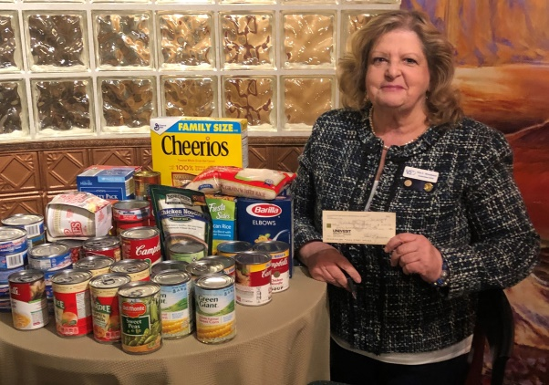
In addition to relaxation techniques from Terri Tosh, owner instructor of Pennsylvania Institute of Massage Therapy, we collected items for the Quakertown Food Pantry. Pictured are the donations and President Rita holding our $500 donations. These were delivered to the Pantry on Wednesday, January 23, where they were accepted by Barbara Cariot (left) and Karen Tkacik (right), food pantry volunteers..

DISRICT 11
SPRING DISTRICT MEETING AND WORLD AFFAIRS LUNCHEON
The Spring Meeting and World Affairs luncheon will be held on April 13 at Maggiano’s restaurant near the King of Prussia Mall. For this year’s event the committee is looking for 2-3 dynamic speakers. Each speaker will be asked to prepare a 20-25 minute presentation based on our theme “Women for a World of Passion and Purpose." Each speaker will have to fill out a Bio form and it will have to be sent to Jennifer Van Ingen by March 1, 2019 jennifervaningen@gmail.com . If you are interested in participating, please contact Rita.

BPW/PA
KEY
The winter edition of the Key is available on the BPW/PA website.

STATE CONVENTION
Registration forms are found on the website, www.bpwpa.org. If you plan to attend, you might want to complete the registration form and take advantage of the advance registration rate of $55. The convention runs from June 6 t- 9 at the Double Tree Hotel near Pittsburgh Meadowlands.

NEWS ABOUT OUR MEMBERS
Rita Woodward thanks all who sent cards, prayers in sympathy for the passing of her father. Judy Guise was honored by the Palisades Republican Cub for her 48 years working with Bucks County Republican Committee at their annual holiday dinner on January 14

WEAR RED FOR WOMEN – February 1
Members of the State House donned red last week to support the American Heart’s annual day. Maybe you can find you representative in this picture.
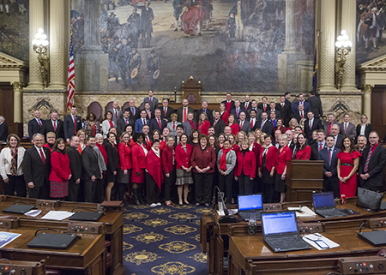

DATES TO REMEMBER
February 26 – Quakertown Membership Meeting
March 4 – Quakertown Board Meeting
March 8 -9 - BPW/PA Winter Board Meeting, Penn Stater Conference Center,
State College
March 26 – Quakertown Membership Meeting
April 13 – District 11 Spring Meeting and World Affairs Luncheon
April 28 – Paddle Raffle
JUNE 6- 9 – BPW/PA STATE CONVENTION, DOUBLE TREE INN, WASHINGTON,

February 16 – Karen Creghan
March 5 – Gail Jancsics
March 7 – Melissa Wieand

Our 2018-2019 Patrons | 