QUAKER QUILL
QUAKERTOWN BUSINESS& PROFESSIONALWOMEN’S CLUB
P.O. BOX 2, SPINNERSTOWN, PA 18968

STATE THEME: CELEBRATING 100 YEARS OF WOMEN HELPING WOMEN WITH PASSION AND PURPOSE
DISTRICT: BE KIND

www.bpwpa.wildapricot.org www.bpwfoundation.org www.BPWQuakertown.org
www.facebookcom/bpwquakertown BPWQuakertown@gmail.com

OFFICERS 2018-2019
President –Rita Woodward Corresponding Secretary – Gladys Benner
Vice-Presidents – Sue Lewis and Linda Lokay Treasurer – Gail Jancsics & Crystal Smith
Recording Secretary – Ellen Miron &Nancy Werner Parliamentarian – Judy Guise

Volume 66 Issue 4 January 2019

NOTE: RESERVATION CONTACT HAS BEEN CHANGED FOR THIS MEETING
January Meeting
Date –January 22
Place – – Arts & Entertainment Center, McCoole’s Restaurant, Quakertown
Time – 5:30 Networking, 5:50 Business Meeting, 6:15 Dinner, 7:15
Menu –Eggplant Parmigiana or Chicken Carbonara. Also included is pita with humus, soup, and coffee or tea. Dessert provided by Linda Bender and Ellen Miron.
Cost - $27
Program – Terry Tosh from the Pennsylvania Institute of Massage Therapy will give us relaxation techniques to help relieve everyday stress.
You can make your reservation by calling Ellen Miron – 215-538-2457 or email ellen_miron@verizon.net RESERVATIONS OR CANCELLATIONS SHOULD BE MADE NO LATER THAN 4:00 pm ON JANUARY 18. PLEASE NOTE: after you reserve if you are unable to attend the meeting, you are responsible for the meal payment.

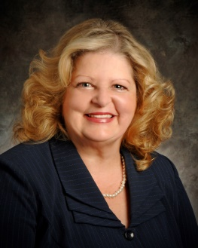
President’s Message
2019…. Happy New Year! Look forward to seeing you at our January Meeting. We have another great program scheduled. 2018- 2019 my goal is to increase BPW Quakertown membership. Ladies, please ask a friend, co-worker or neighbor to join us …it might be just what they were looking for to do in the community.
See you at the meeting!
Rita
NOTE: Birthday girls – remember your donations for our Birthday Bucket. Any donation is graciously accepted.

LOCAL PROJECTS
LOTTERY TICKETS
Thanks to all who sold tickets for our December Lottery. Proceeds netted $880. Missy Wieand felt this was a great month to hold the lottery. Plans are to repeat later this year.

CHRISTMAS PROJECT
We collected $180 at the Christmas Party for the Quakertown Food Pantry. At the January Board meeting a motion was made to donate $500 from our club community outreach funds. In addition we are asking members to bring non-perishable items to the January meeting and these plus the donation will be taken to the pantry. Items needed are Hot cereal, saltines, Jelly (no grape), individually wrapped Healthy snacks, canned pasta sauce, dry pasta, canned chicken or tune, dry milk, rice or pasta side dishes, baked beans, or juice (100% individual boxes or bags)

PADDLE RAFFLE
Save the date – April 28, 2018. Tickets have been printed and will be distributed at the January meeting. Missy is going to use a different method this year which she will explain at the meeting. If you are unable to attend the meeting and would like tickets, please call her (215-536-2914).

VOUCHER FORMS
To make our treasurer’s life easier, you will need to complete a voucher form to receive reimbursement from the club. These forms will be available at our meetings or via email from Gail Jancsics, Judy Guise, or Rita Woodward.

PICTURES FROM THE NOVEMBER MEETING AND HOLIDAY PARTY

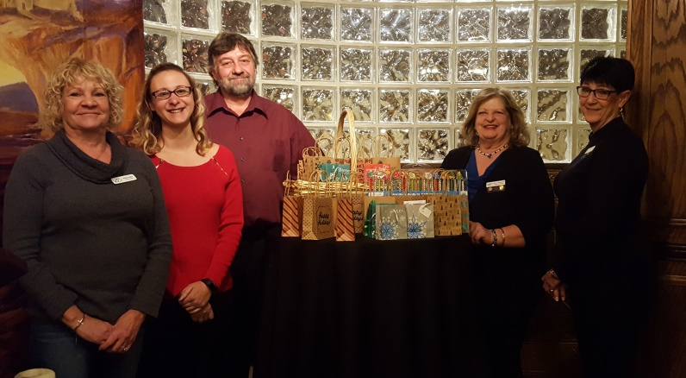
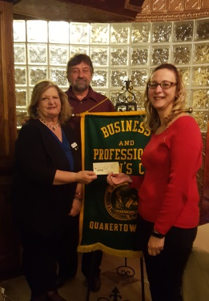
Our November meeting featured a presentation from Quakertown Community Outreach. Nicole Remick and Dave Hammerschmidt explained their projects. Our members donated gift cards for children’s Christmas presents as well as cash donations.
Above – President Rita presents a check to Nicole and Dave..Right– from left to right – Patty Fuller, Nicole, Dave, President Rita, and Sue Lewis surround the bags of gift cards.
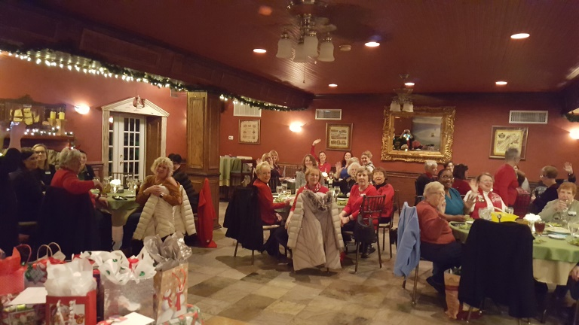

On December 11, Quakertown and Upper Perkiomen enjoyed a great evening of holiday fellowship. We were treated to a storytellers recounting of one of her favorite Christmas celebrations. Donations were collected for each club’s Holiday Project and the annual ornament exchange was held.

DISTRICT 11
BLANKET DAY
On January 12 District 11 made blankets for the little kid’s cots at the Pottstown YWCA. All club in were represented and about 20 people attended. Look for pictures in the February Quill.

BPW/PA
KEY
The winter edition has been emailed to you. If you haven’t received it, please let Rita, Missy Wieand, or Nancy Werner know.
Dawn Berkebile, our President-Elect, was diagnosed with Breast Cancer and is undergoing treatment. We extend our prayers and concerns to her. If you wish to send Dawn a card, her address is 281 Wicklow Lane, Ligonier, PA 15658.

NEWS ABOUT OUR MEMBERS
We are happy to report that Linda Lokay is recovering from a recent procedure and is on the road to recovery. Our club was saddened by the death of Rita’s father. We extend our sympathies and will keep you and your mother in our prayers. Elfriede Werner’s daughter, Rosemary suffered a stroke and is undergoing therapy. We extend our prayers and concerns to Elfriede.

JANUARY - 20 - Ellen Miron

DATES TO REMEMBER

January 22 – Quakertown Membership Meeting
February 2 – Upper Perkiomen Oldies Dance, East Greenville Co. Call Marilynn Mayer
215-679-7151 for tickets
February 4 – Quakertown Board Meeting, PA Institute of Massage Therapy, Quakertown
February 8 – National Wear Red for Women Day
February 26 – Quakertown Membership Meeting
March 8 -9 - BPW/PA Winter Board Meeting, Penn Stater Conference Center,
State College
April 13 – District 11 Spring Meeting and World Affairs Luncheon
JUNE 6- 9 – BPW/PA STATE CONVENTION, DOUBLE TREE INN, WASHINGTON, PA

If you are looking for a fun night, try Bible Bingo, An Act of Charity in Two Acts, at the Our Lady of the Sacred Heart Gymnasium, Hilltown, on January 26. Bible Bingo is a comedy of God, Games, and Goofy Prizes. Doors open at 6:15, show starts at 7. Tickets are $25 and can be purchased online at www.olsh-hilltown.com/parish100biblebingo

Our Patron page has room for more advertisements. If you are interested, send or give Judy Guise your business card. Cost $10 per year. If you have not paid for your ad, please remit $10 to Gail Jancsics.

Our 2018-2019 Patrons

