QUAKER QUILL
QUAKERTOWN BUSINESS& PROFESSIONALWOMEN’S CLUB
P.O. BOX 2, SPINNERSTOWN, PA 18968

STATE THEME: CELEBRATING 100 YEARS OF WOMEN HELPING WOMEN WITH PASSION AND PURPOSE
DISTRICT: BE KIND

www.bpwpa.wildapricot.org www.bpwfoundation.org www.BPWQuakertown.org
www.facebookcom/bpwquakertown BPWQuakertown@gmail.com

OFFICERS 2018-2019
President –Rita Woodward Corresponding Secretary – Gladys Benner
Vice-Presidents – Sue Lewis and Linda Lokay Treasurer – Gail Jancsics & Crystal Smith
Recording Secretary – Ellen Miron &Nancy Werner Parliamentarian – Judy Guise

Volume 66 Issue 3 November/December 2018

THIS NEWSLETTER CONTAINS INFORMATION FOR NOVEMBER & DECEMBER

November Meeting
Date –November 27
Place – – Arts & Entertainment Center, McCoole’s Restaurant, Quakertown
Time – 5:30 Networking, 5:50 Business Meeting, 6:15 Dinner, 7:15
Menu – Chicken Marsala or Shrimp Scampi. Also included is pita with humus, salad, and coffee or tea. Dessert provided by Janet Bonekemper
Cost - $27
Program – Dave and Nicole Remick from Quakertown Community Outreach. Members attending are encouraged to bring gift cards from Target or Walmart. Small denominations please.
You can make your reservation by calling Cathy Somich – 215-536-8526 or email gcsomich@yahoo.com. RESERVATIONS OR CANCELLATIONS SHOULD BE MADE NO LATER THAN 4:00 pm ON NOVEMBER 23. PLEASE NOTE: after you reserve if you are unable to attend the meeting, you are responsible for the meal payment.

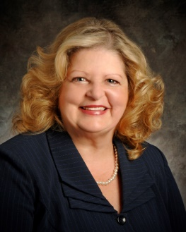
President’s Message
With the Holiday Season right around the corner it all starts with my favorite time of the year Thanksgiving. Food, Food and more Food with Friends and Family. I love the prep, shopping and most of all cooking for my Family and Friends and to be able to sit back and just ENJOY THEM before the craziness truly begins. This year at our November 27th meeting we are collecting Gift Cards for Quakertown Community Outreach. More details in my e-mail of November 7, 2018. Quakertown Community Outreach will be our program and let’s show them how much BPW Quakertown Cares for our community.

To You and Your Family wishing you all of the Hope, Wonder and Joy that the Season can bring!
Rita
DECEMBER HOLIDAY PARTY
Our Holiday Party will be on December 11 at McCoole’s Arts and Entertainment Center in Quakertown. We will socialize from 6:00 – 6:30 and dinner will follow.
Menu for the evening is Sliced Roast Beef or Broiled Crab Cake.
Cost of the dinner is $30.
Please make your reservations by December 4 to Cathy Somich 215-536-8526 or email gcsomich@yahoo.com.
Upper Perkiomen always has an ornament exchange. If you wish to participate in this bring a wrapped ornament (value $5). We will be passing baskets for each club’s Christmas project.

NOTE: Birthday girls – remember your donations for our Birthday Bucket. Any donation is graciously accepted.

LOCAL PROJECTS
LOTTERY TICKETS
We are selling lottery calendars for December to fund our community outreach. All money and stubs will need to be turned in to Melissa Wieand at our November meeting or by November 30.
CHRISTMAS PROJECT
We will collect monetary donations for the Quakertown Food Pantry as our 2018 project. Please bring these to the holiday party. In January the board will make an additional amount to the moneys collected in December.
PADDLE RAFFLE
Save the date – April 28, 2018. More information will appear in later editions of the Quill.

LOCAL NEWS
EXECUTIVE BOARD REPORT
Thank you notes were received from the Quakertown SPCA for our donation in memory of Linda Sepenthal, from Amy’s Run, Ride, and Walk in April, and Bucks County Community College Foundation for our $250 sponsorship of their Salute to Mother’s Scholarships..
The Board voted to be a snowman sponsor ($450) for the Shop with a Cop program on December 13. Kids are given a Walmart gift card and shop with officers from the Quakertown and Richland Township police force.

QUAKERTOWN DIRECTORY
Directories were distributed at the October meeting. If you have not received yours, please contact Rita.
NEW MEMBERS
Jessica Mann and Georgia Wilson will be inducted at our November Meeting. They join Pat Mullen and Patty Fulmer as new members for this year. Their contact information will appear in the 2018-2019 Directories Name tags will be given to the new members at the October Meeting.
VOUCHER FORMS
To make our treasurer’s life easier, you will need to complete a voucher form to receive reimbursement from the club. These forms will be available at our meetings or via email from Gail Jancsics, Judy Guise, or Rita Woodward.

NEWS ABOUT OUR MEMBERS
Our Club was saddened by the passing of 2 former BPW/PA Presidents – Joyce Bresee and Paulette Keifer. We are also happy to report that Linda Lokay is recovering from a recent procedure. Congratulations to the new Treasurer of the Ironton Telephone Company, Nancy Werner.

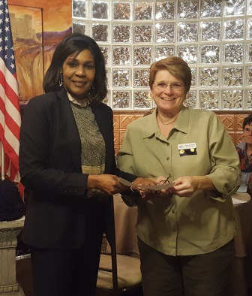
PICTURES FROM THE OCTOBER MEETING
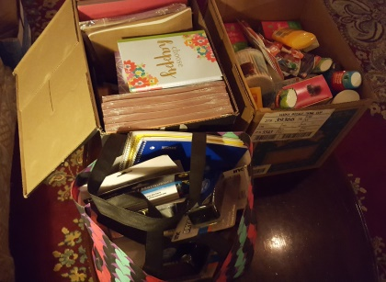
School supplies and health items - Card stock – any color, Art supplies, journals, Face wash with salicylic, deodorant, toothbrushes, feminine products, writing paper, one subject notebooks, pencils, pens, dry eraser board markers and cleaners were presented to Stacey Coleman from the Pottstown YWCA. Left – Missy Wieand presents donation to Stacey Coleman from Pottstown YWCA. Right – school supplies collected by our Quakertown BPW Members

DISTRICT 11
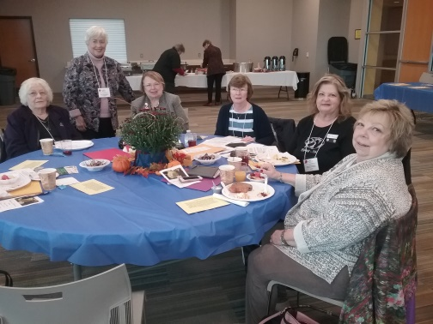
FALL MEETING
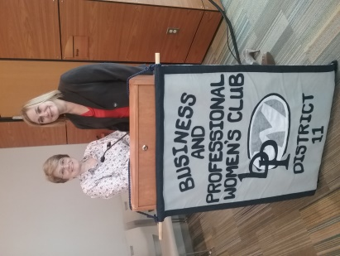
District Fall meeting was held on October 27 at the Montgomery Recreation Center. District Director Melissa Wieand presided. BPW/PA President-Elect Dawn Berkebile made her official visit. 9 members from our club attended. Left – Missy and Dawn. Right – Shirley Andres, Janet Bonekemper, Nancy Werner, Gail Jancsics, Rita Woodward, and Toni Rubic are waiting for meeting to begin.
Missing from picture are Missy Wieand, Sheryl Nierenberg, and Judy Guise

BLANKET DAY
On January 12 at Melissa Wieand’s home, district 11 will be making blankets for the little kid’s cots at the Pottstown YWCA. We are permitted 6 members per club. If you are interested in attending, please notify Rita.

BPW/PA
KEY
The Fall edition has been emailed to you. If you haven’t received it, please let Rita, Missy Wieand , or Nancy Werner know.

NOVEMBER – 19 - Gladys Benner, 23 – Georgia Wilson
DECEMBER – 2 - Linda Bender
JANUARY – 5 - Melissa Padera, 10 – Jessica Mann

DATES TO REMEMBER

November 27 – Membership Meeting
December 11 – Holiday Party
January 7 – Quakertown Board Meeting
January 12 – District 11 Blanket Making Day, snow date January 19

Our Patron page has room for more advertisements. If you are interested, send or give Judy Guise your business card. Cost $10 per year.

The Executive Board wishes everyone a Merry Christmas and a very Happy 2019
Our 2018-2010 Patrons

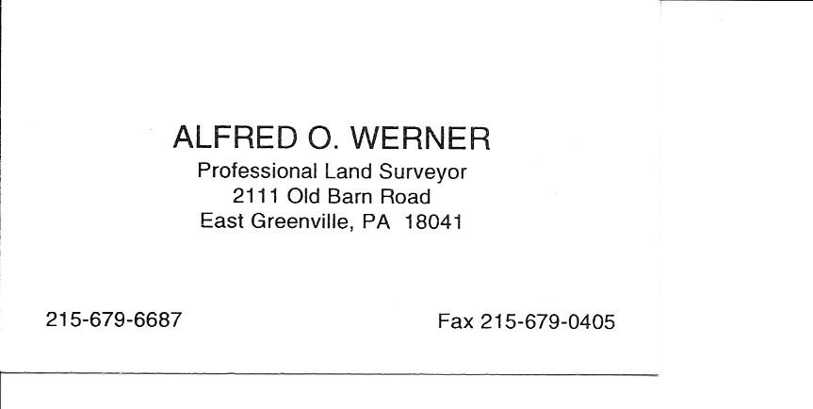
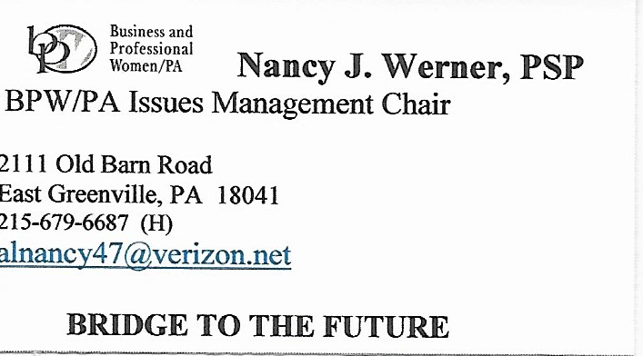
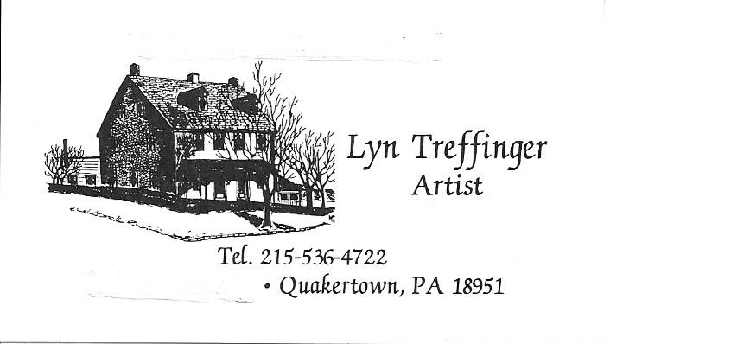

Christmas Shopping Opportunities

Our Lady of the Sacred Heart presents...
14th Annual Christmas Bazaar & Craft Fair
Saturday, December 1 ◆ 9:00 am - 4:30 pm
Sunday, December 2 ◆ 9:00 am - 2:00 pm
See olsh-hilltown.com for more info!
Crafters & Vendors ◆ Delicious Foods ◆ Daily 50-50 ◆ Santa’s Attic ◆ Bake Table
Basket Raffle ◆ Gems & Jewels ◆ Book Nook ◆ Parish Raffle
Celebrating 100 Years as a Parish Family

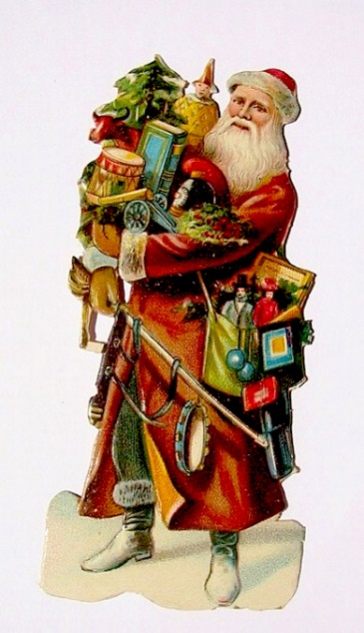

Kringle Christmas Shoppe XV
Haycock Township Community Center
1014 Old Bethlehem Road
Applebachsville, PA
December 7 10 – 6
December 8 10 – 6
December 9 10 -4

