QUAKER QUILL
QUAKERTOWN BUSINESS& PROFESSIONALWOMEN’S CLUB
P.O. BOX 2, SPINNERSTOWN, PA 18968

STATE THEME: CELEBRATING 100 YEARS OF WOMEN HELPING WOMEN WITH PASSION AND PURPOSE
DISTRICT: BE KIND

www.bpwpa.wildapricot.org www.bpwfoundation.org www.BPWQuakertown.org
www.facebookcom/bpwquakertown BPWQuakertown@gmail.com

OFFICERS 2018-2019
President –Rita Woodward Corresponding Secretary – Gladys Benner
Vice-Presidents – Sue Lewis and Linda Lokay Treasurer – Gail Jancsics & Crystal Smith
Recording Secretary – Ellen Miron &Nancy Werner Parliamentarian – Judy Guise

Volume 66 Issue 1 September 2018

President’s Message
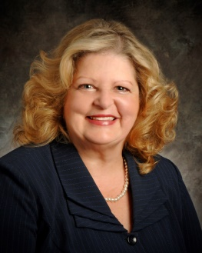
Hello BPW Quakertown Ladies,
Thank you once again for putting your trust in me to be your President for 2018-2019 year!
September we are starting off with our 65th Birthday Party September 25, 2018 at The Proper Brewing Company and you will not want to miss this celebration. Invite a friend or two. See section below for more details. Thank you to Toni Rubic and Nancy Werner for co-chairing this event.
October to May meetings will be at McCoole’s. Side Salad in the warmer months and soup in the colder months. Cost will be $27.
Welcome to our new and our existing members. We hope to increase membership again in 2018-2019. Do you know someone that would enjoy our monthly meeting and activities that we do at BPW Quakertown? Invite them to the 65th Birthday Party on September 25th! Remember wear your Sapphires!
Handbook will be given out at the October meeting. Do you have any changes from last year? If so please send to Rita before September 20th. Thank you!
Thank you for all you do for BPW Quakertown,
Rita
September Meeting – Quakertown BPW 65th Birthday celebration
Sapphire Anniversary – so please wear your sapphires and blue
Date – September 25
Place –Proper Brewing Company Restaurant, 117 West Broad Street, Quakertown
Time – 5:30 Networking, 6:00 Dinner
Menu – Buffet and birthday cake. A cash bar will be available
COST - $30. RESERVATIONS TO Cathy Somich – 215-536-8526 or email gcsomich@yahoo.com BY SEPTEMBER 14. SEND CHECKS TO GAIL JANCSICS, 40 SOUTH VASSAR DRIVE, QUAKERTOWN. NO MONEY WILL BE COLLECTED NIGHT OF PARTY.

Entertainment – Kate Campbell Stevenson, known for her Back to History performances, will portray Eleanor Roosevelt. Kate is a fellow BPW member from Silver Spring Maryland

LOCAL PROJECTS
LOTTERY TICKETS
We are selling lottery calendars for December to fund our community outreach. Tickets will be available at the September meeting. All money and stubs will need to be turned in at our November meeting.

HALLOWEEN PARADE– OCTOBER 21
Capitalize on the birthday theme. Sheryl Nierenberg has agreed to coordinate. If you are interested in walking in the parade or helping with preparations, please contact her at the September meeting or call 215-536-2914. Last time we entered, we came in 4th.

PADDLE RAFFLE
Save the date – April 28, 2018. More information will appear in later editions of the Quill.
QUAKERTOWN BPW NIGHT at Panera Bread
In May, we will have a fundraiser at the Panera Bread Restaurant in Quakertown. More information will be coming.

LOCAL NEWS
NAME TAGS
New members will receive their tag at the October meeting
QUAKERTOWN DIRECTORY
These will be available at the October meeting. Please check your listing in the 2017-2018 directory and notify Rita of any changes by October 1. It will also include program information and your committee assignments. Thanks so much for volunteering to assist committee chairs.

BLAZERS THANK YOU
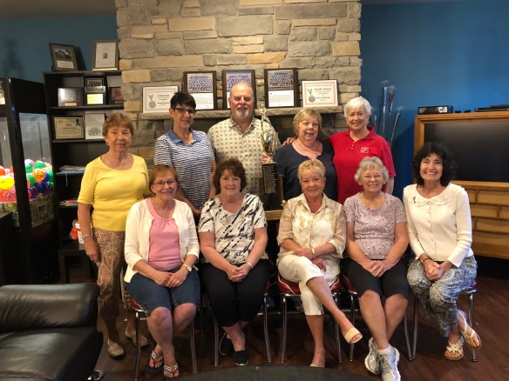
George Bonekemper sent a beautiful thank you letter and check to Quakertown BPW for our volunteering at the front gate and refreshment stand at the Blazers Games. A tip jar was located in the refreshment stand and the Blazers were happy to remit $100 to us. Thanks to all members who gave their time to support the team, especially Nick and Ellen Miron who covered the front gate. By the way, the Blazers won the championship of the Atlantic Collegiate League. BPW members who helped with the front gate and refreshment stand were treated to an ice cream social at The Scoop in Coopersburg.

SCHOLARSHIP WINNERS
Rylie Hetrick (attended our June picnic with her parents) plans to attend York College. Her career goal is to become a Pediatric nurse practitioner.
Erick Pagan is a Machining Technology graduate from Upper Bucks Technology School. He is planning his first year at Bucks County CC and then transfer to a 4 year college. His goal is to own a machine shop specializing in custom made parts.

EXECUTIVE BOARD REPORT
A $50 donation will be sent to the Quakertown SPCA in memory of Linda Sepenthal. The SPCA was very dear to Linda and she spent as much time as she could helping at their facility.
A Thank you note was received from the Sarah Parvin Foundation thanking us for the baked goods and sponsoring the sweet tent.
QUAKERTOWN BIRTHDAY BUCKET
This is how each BPW in Pennsylvania can participate in President Theresa’s state project. Each member is asked to donate their age in coins to the bucket during her birthday month. The amount can be pennies, dimes, or dollars. For example the editor’s birthday is in September. She will be bringing 74 dollars to place in the bucket.

DISTRICT 11
FALL MEETING
The Fall District Meeting will be held on October 27 at the Montgomery Township Recreation Center. BPW/PA President-Elect Dawn Berkebile will be making her official visit. If you are able to attend, please contact Rita. Reservation deadline is October 11.

DISTRICT WORKING WITH POTTSTOWN YWCA
Since BPW/PA President Theresa’s project is the YWCA, District Director Melissa Wieand has met with the Executor Director of the Pottstown YWCA and asked how we can assist with their programs. One way is to collect school supplies. In the October Issues a list of needed items will be printed. You can bring these to any of our meetings.
DISTRICT BIRTHDAY BUCKET
To help with BPW/PA President Theresa’s state project, YWCA, District Eleven is asking members who attend the Fall District Meeting and have birthdays between July and December, the bring a donation reflecting their age for the District Birthday Bucket. Members attending the Spring District Meeting and have birthdays between January and June will bring their donations.

BPW/PA
KEY
The Key has a new editor and she is doing a fantastic job. If haven’t looked at the September issue, click on the website in our mast head or type in the address on your browser. The next edition will be out soon.
ELECTIONS
The editor is serving as Legislative Chair for this year. If you are not registered to vote, you need to complete a registration form and mail it to your county election Board by October 8. You cannot vote, if you are not registered. Forms can be found on line on your county website. Governor, Lt. Governor and U.S. Senator will be elected statewide. All Congress members will be elected. All members of the Pennsylvania House and ½ of the Senators will be chosen.

NEWS ABOUT OUR MEMBERS
We were saddened by the death of Linda Sepenthal on July 22. A memorial service will be held in spring 2019. We are also thrilled to have Melissa Wieand as District 11 Director.

SEPTEMBER BIRTHDAYS
29 – Crystal Smith
30 – Cathy Somich, Judy Guise

DATES TO REMEMBER

September 25 Quakertown 65th Birthday Celebration
October 2 Quakertown Executive Board
Massage Therapy School, Quakertown
October 10 Last Day to Register to Vote
October 21 Quakertown Halloween Parade
October 23 Quakertown Membership Meeting
October 27 District 11 Fall Meeting

ATTENTION PATRONS
The following page contains the business cards from last year. If you wish to use this card again, just send $10 to Gail Jancsics. If you are a new patron, please send a card to me – jmisguided70@gmail.com or give it to me at the September meeting and send $10 to Gail.
I have space for at least one more and can always make additional pages.

Our 2018-2010 Patrons | 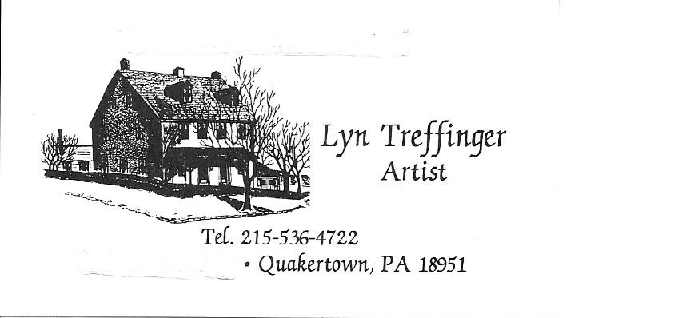
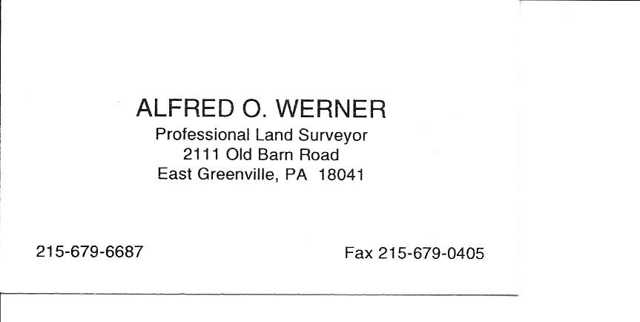
 | 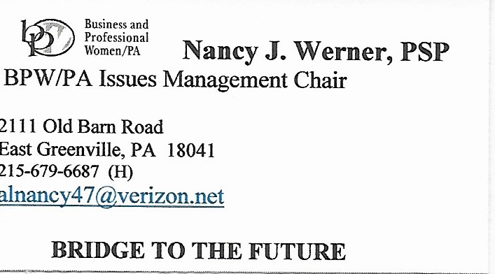
 | 