DONATION FORM 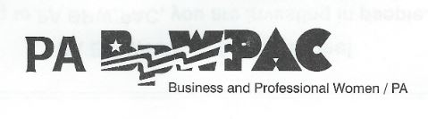
PA BPW/PAC is for Everyone!
By contributing to PA BPW/PAC, you are investing in people. People who have the power to decide where your tax dollars will go. People who will give voice to the concerns of working women and their families. PA BPW/PAC was established in 1988.
Yes! I want to make an imPACt!
…by helping to elect more women and pro-women candidates with my contribution of:
$25 $50 $100 $150 Other $_____________
Make Checks Payable to: PA BPW/PAC

Contributor Information PA BPW/PAC
The following information is required by the State Election Commission*
Type or print to fill in the form below. Provide ALL of the information requested. Thank you!
What will involvement mean to me?
My contribution to PA BPW/PAC gives me the opportunity to have a greater impact on the political and legislative process. I understand contributions and endorsements will be made to those candidates at the state and /or local level who support our BPW Legislative Platform. My contribution is voluntary. I understand that PA BPW/PAC is bi-partisan, non-profit and legal.
Name _____________________________________________________________
Address ___________________________________________________________
City/State/Zip________________________________________________________
Day Phone ______________________ Home Phone_________________________
BPW District Number _________________
I give my permission for my name to be published as a contributor in The Key and the State Convention Manual.

Please mail this form and your check to BPW/PA PAC Treasurer: Marion Waelchli
1744 Route 588
Fombell, PA 16123
*A copy of our report is filed with the State Election Commission.

