Enclosed Is a tax deductible gift of $______. Your contribution is tax deductible to the extent permitted by law.

Name: ___________________________________________________________________________________

Address: ___________________________________________________________________________________

Telephone #:____________ Email: ______________________________________________________

BPW Member Local: _______________________________________ District: ____________________

Make checks payable to PA BPW Foundation. Mail all contributions and donation forms to:

Joyce Turner, PA BPW Foundation, Treasurer, 282 Honeysuckle Lane, Robesonia, PA 19551

You may designate your gift for: No designation Scholarship Fund Edith Oler Flanigan Fund Grant

Contribution in memory/honor of: _____________________________________

Your contribution is tax deductible to the fullest extent of the law. A copy of the official registration and financial information may be obtained from the PA Department of State by calling toll free, within PA 800-732-0999

Registration does not imply endorsement.

What Is
PA BPW Foundation, Inc.

The PA BPW Foundation was established in 2008 as a 501(c)(3) organization.
All money donated to either the Scholarship Fund or Edith Oler Flanigan Fund Grant is restricted for use by the guidelines established for each fund. Our donors can designate their gifts to support either fund as charitable contributions.

The Board of Directors consists of eleven BPW/PA Federation members. Three are officers of the BPW/PA Federation. The remaining eight are active members of the BPW/PA Federation.

PA BPW Foundation is a separate entity from BPW/PA. The grants and scholarship applications are reviewed by a scholarship committee appointed by the PA BPW Foundation and recommendations are made to the Board of Directors of the Foundation who make all final decisions.
PENNSYLVANIA BUSINESS AND PROFESSIONAL WOMEN’S FOUNDATION, INC.

SCHOLARSHIP FUND

and

EDITH OLER FLANIGAN
FUND GRANT

Scholarship Fund

Provides grants for individuals who:

- Are interested in furthering their educations;
- Have proven financial need;
- Are United States citizens;
- Meet the requirements set forth in the scholarship application;
- Have been a paid member of BPW/PA or a resident of Pennsylvania for at least two years prior to application;
- Submit a complete application with supporting data to the PA BPW Foundation scholarship committee.

Deadlines:
May 1 for Fall term
November 1 for Spring term

Applications subject to approval by
PA BPW Foundation, Inc.

Edith Oler Flanigan
Fund Grant

Provides funds for members of BPW/PA to draw upon in emergencies such as:
- Catastrophic illness or accident;
- Extended unemployment;
- Disaster or any other unusual financial loss.

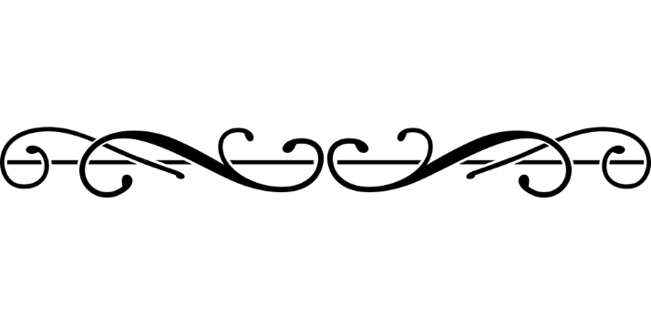

MISSION

Provides full participation, equity, and economic self-sufficiency for America’s working women.

HOW TO APPLY

Applications for scholarships can be found on www.bpwpa.org

The Edith Oler Flanigan Fund Grant can be found in the member login section of www.bpwpa.org

OR

Contact
Laura Whetstone
PA BPW Foundation Vice-Chair

Lwhetstone77@gmail.com

OR

A member of the PA BPW Foundation Board of Directors
Revised 6/2019

