QUAKER QUILL
QUAKERTOWN BUSINESS& PROFESSIONALWOMEN’S CLUB
P.O. BOX 2, SPINNERSTOWN, PA 18968

STATE THEME: LET YOUR DREAMS TAKE FLIG DISTRICT THEME: JUST BE

www.bpwpa.wildapricot.org www.bpwfoundation.org www.BPWQuakertown.org
www.facebookcom/bpwquakertown BPWQuakertown@gmail.com

OFFICERS 2019-2020
President –Linda Moskal Corresponding Secretary – Gladys Benner
Vice-Presidents –Jeanne Schlicher &Georgia Wilson Treasurer – Crystal Smith
Recording Secretary – Ellen Miron Parliamentarian – Toni Rubic

Volume 68 Issue 4 January 2021

COVID RESTRICTIONS –To comply with the Governor’s requirements, we are asking members to wear a mask during the business meeting and speaker’s presentation. We are requesting McCoole’s to use 4 seats per table to allow for social distancing.

JANUARY MEETING
Date - January 26 – Greeter & Photographer is Melissa Wieand
Place - Arts & Entertainment Center, McCoole’s Restaurant, Quakertown
Time – 5:30 Networking, 5:50 Business Meeting, 6:15 Dinner, 7:15 Program.
Menu –Chicken Marsala or Marinated Beef Tenderloin. Included is pita with humus, soup, and coffee or tea. Dessert provided by Melissa Wieand and Sheryl Nierenberg
Cost - $28 (Note price increase
Program – Georgia Wilson will present “Seven Pearls of Wisdom”. You can make your reservation by calling Ellen Miron – 215-538-2457 or email ellen_miron@verizon.net. RESERVATIONS OR CANCELLATIONS SHOULD BE MADE NO LATER THAN 4:00 pm ON January 22. PLEASE NOTE: after you reserve if you are unable to attend the meeting, you are responsible for the meal payment.
(Picture from the Treffinger Collections)

PRESIDENT’S MESSAGE
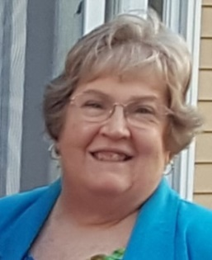
Ladies!
Welcome to 2021! While the first weeks of the year haven't demonstrated it, this is a new, better year than the one we just left! I can see the light at the end of the tunnel ... even though it may still be a long tunnel ... and so we are going ahead with our in-person meetings! I hope you will join us at the January 26th meeting at McCoole's when our Vice President, Georgia Wilson, will be enlightening us with her "Seven Pearls of Wisdom." I'm intrigued and looking forward to learning more! Linda M.

LOCAL NEWS
PROJECTS:
LOTTERY TICKETS
Many thanks to all who sold tickets for the January Pick 3 evening drawing. We sold 360 tickets and have $1800. Hopefully we will be okay after all numbers are drawn and checks sent out. Melissa will be sending updates through the month.
SAVE THE DATE – APRIL 18, 2021.
More information will be coming in later editions of the Quill and future meetings.
CHRISTMAS PROJECT
Because we didn’t have our holiday party and donations to the Food Pantry were not collected, the Board has decided to put out a request for members to bring or send monetary donations. If paying by check, make it payable to Quakertown Food Pantry. If you are unable to attend the January meeting, please send it to Crystal Smith, 2325 Willow Stream Drive, Quakertown, PA 18951.

INDUCTION
Brenda Hoot will be inducted at the January Meeting by Pat Mullen. Her information will be added to the direct insert sheet. (See directories)

DIRECTORIES
These have been delivered or will be shortly. There was an omission and Brenda Hoot’s information will be included in a separate sheet that you will be able to insert in your booklets. Thanks to Linda Moskal and Georgia Wilson for compiling and printing these.
.
DISTRICT 11
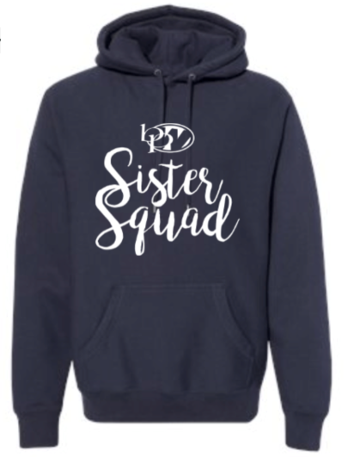
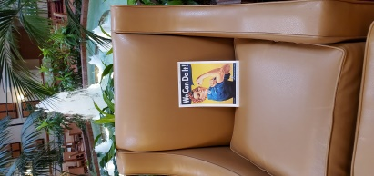
Conshohocken BPW had a contest in November to see where Rosie the Riveter could be found. The editor submitted a few entries. This one has a dual purpose – shows Rosie at the Marriott in Cranberry awaiting us for our convention in June.

Upper Perkiomen BPW
Tina Thomas is making the item below available for purchase. If you need a new sweatshirt, you might place an order with Tina.
Check out the new BPW Spirit Wear!
https://upbpw.spiritsale.com/products

BPW/PA
Don’t forget to check the weekly Buzz to find out other projects or Zoom activities that might be of interest to you.

Legislative Alert
In the 2020 legislative session a constitutional amendment was passed in both the PA Senate and House. It would change the organization of our appellate courts. The next step is for the amendment to pass the House and Senate this session. If the amendment is passed by the General Assembly and Senate without change, it goes to the voters in either the 2021 Primary or General Election. You might want to contact your State Rep – Craig Staats or Milou Mackenzie or Senator Mensch about this change. I am attaching an article explaining the change.

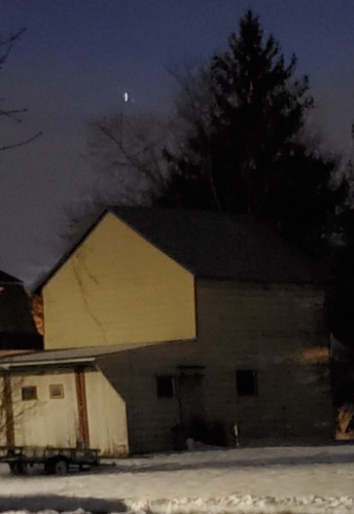
Convergence
The weather didn’t cooperate on December 21, but I took this on December 23. They appear together although there was a little bit between Jupiter and Saturn. Another planet grouping appeared this past week. I tried to see the conjunction with Mercury, but it didn’t get dark before they disappeared below the horizon.

BIRTHDAYS
January 20 – Ellen Miron

DATES TO REMEMBER

January 20 Inauguration of President Biden
January 26 Quakertown Membership Meeting
February 2 Quakertown Board Meeting
February 6 National Wear Red for Women – American Heart Association
February 18 Presidents Day
February 23 Quakertown Membership Meeting
June 10 – 13 BPW/PA 101st State Convention
Pittsburgh North Marriott

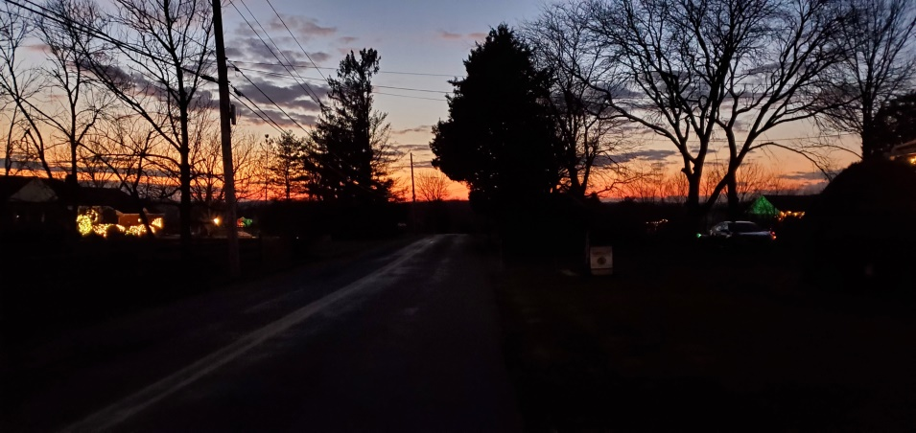

If you wish to include your business card in the Quill, please send or give to Judy Guise and remit $10 to Crystal Smith. Thanks

2020 -2021 PATRONS

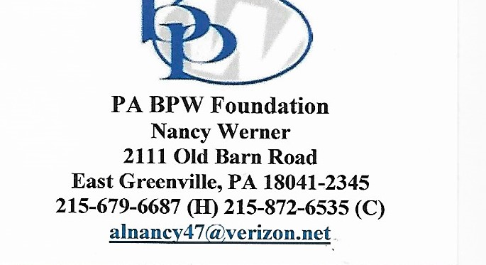

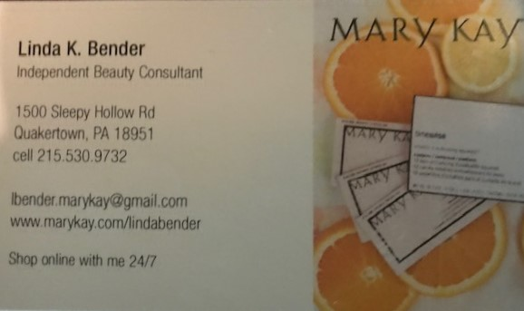 | 