

**UNIONTOWN LOCAL ORGANIZATION OF THE PENNSYLVANIA FEDERATION**

**BUSINESS & PROFESSIONAL WOMEN’S CLUBS, INC.**

NIKE NOTES 2020



DINNER MEETING

NATIONAL BUSINESS WOMEN’S WEEK

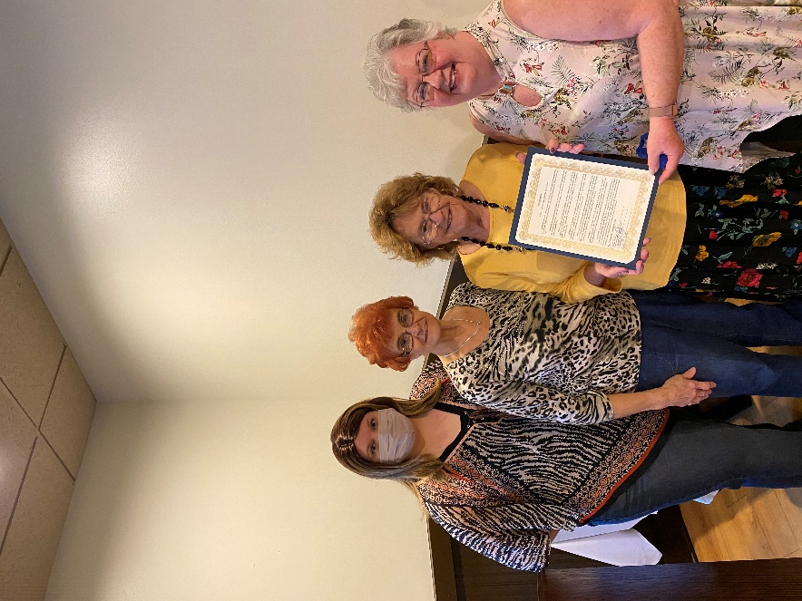

**The PAC Committee with Kathy Cohen chair invites you to the November Dinner Meeting.**

**PLACE: Country Club**

**DATE: November 18, 2020**

**TIME: Networking 5:30**

**Dinner 6:00 P.M.**

**MENU: Choose from the menu**

**PROGRAM: Dorothy Gruskowski**

**Topic: Turkey**

**The Fayette County Commissioners presented**

**a National Business Women’s Week proclamation to BPW**



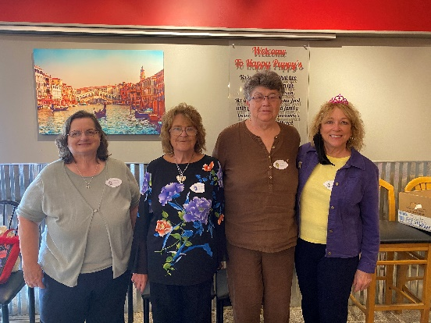

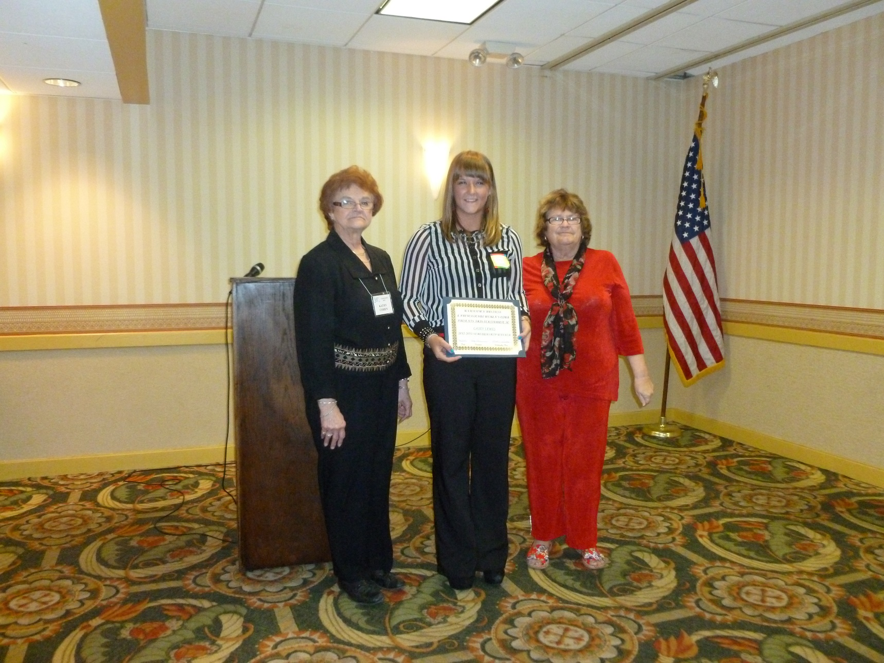

**Hello everyone! Now that the elections are over and things are getting back to normal I hope you are all well. It was really great seeing all of you last month and that we are still wearing our mask.**

**I want to wish you all a very Happy and Blessed Thanksgiving with your families.**

**Mark your calendars for the November 18th meeting at the**

**Uniontown Country Club.**

**See you then Co-President Kathy**

**See you then Co-President Kathy**

**PRESIDENT'S MESSAGE**

**Linda Martin 12/03**

DISTRICT 12 OFFICERS