"To achieve equality for all women in the workplace through advocacy, education,
and information."
HELLO,

UPPER PERKIOMEN BPW

IN PERSON WORKSHOP

SIGN UP

TODAY
Jennifer
610-350-7060

Jennifervaningen @gmail.com

901 Main Street Pennsburg, PA 7:45am - 4:00pm
$25: Includes Course Materials, Light Breakfast and Lunch

FEBRUARY 25

RECONNECT WITH YOUR STRENGTHS
Lets explore what you excel at, and develop new strategies that will carry you into the future

EXPLORE YOUR COMMUNICATION SKILLS
Communication Is one of the most Important parts of our lives. You will learn how to effectively communicate In your personal and professional life.

SHARE, LAUGH AND LEARN
We will share from our own experiences, enjoy the camaraderie of the women around us, and learn how to take ourselves it to the next level

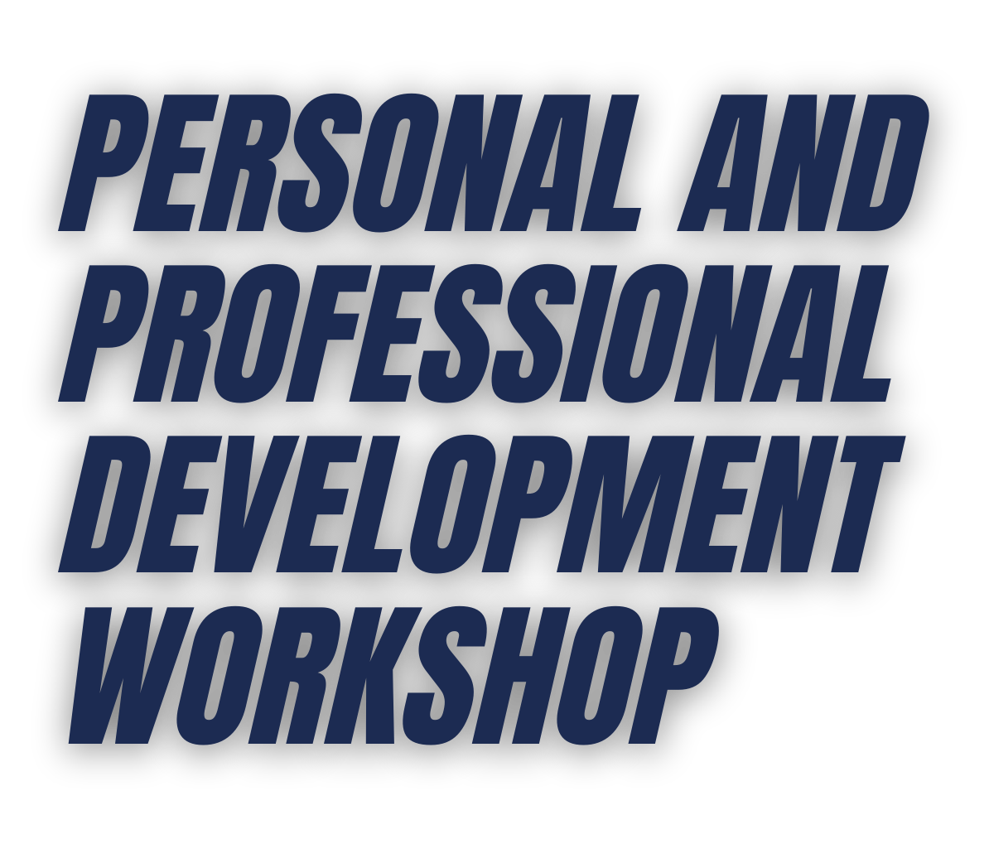bpwupperperk.org

WOMEN SUPPORTING
WOMEN

