QUAKER QUILL
QUAKERTOWN BUSINESS& PROFESSIONALWOMEN’S CLUB
P.O. BOX 2, SPINNERSTOWN, PA 18968

STATE THEME: Grow Through What You Go Through
DISTRICT THEME: Count Your Blessings

www.bpwpa.wildapricot.org www.bpwfoundation.org www.BPWQuakertown.org
www.facebookcom/bpwquakertown BPWQuakertown@gmail.com

OFFICERS 2023-2024
Co-Presidents – Linda Moskal & Jeanne Schlicher Corresponding Secretary – Gladys Benner
Vice-President – Diane Sodano Treasurer – Crystal Smith
Recording Secretary – Nancy Werner Parliamentarian – Toni Rubic
Volume 71 Issue 8 April, 2024

APRIL MEETING
Date: | April 24, 2024
Place: | Perkiomen Valley Brewery, 101 Walnut St., Green Lae, PA
Menu: | There is a food truck called Cast Iron Creations that will be on the lot. Website: www.castironcreations.info for menu. There is also Chiaro’s Pizzeria Restaurant across the street, 124 Gravel Pike, Green Lane. Website: www.chairospizza.com for menu. Or eat at home before you come to meeting. If you eat at either Cast Iron or Chiaro’s or if you want drinks at the Brewery, you will be paying for it on your own.
Program: | April is Autism Acceptance Month. Tom & Kelly Weiss, who own the Brewery, have two sons with autism, and Kelly will speak to us about how this has impacted their family and the family business.
 | PLEASE WEAR BLUE TO THIS MEETING

Perkiomen Valley Brewery does want to know how many of us will be attending, so you will still need to contact Cathy Somich with your reservation. Call Cathy Somich at 215-536-8526 or email her at gcsomich@yahoo.com. Cell (267) 342-6200 for text msg. only. RESERVATIONS SHOULD BE MADE NO LATER THAN 8:00 pm on Sunday, April 21. 2024.

CO-PRESIDENT’S MESSAGE
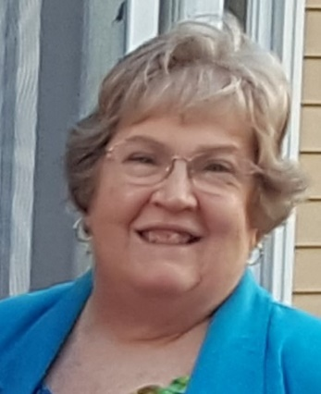
Ladies,
Before I start, I want to take a point of personal privilege and say a huge "Thank You" to all of you for your kind texts, emails, cards, letters, and visits after my mother's death last month. It certainly helped make a difficult situation easier, knowing so many of my "sisters" were supporting me and my family.

On a lighter note, I hope you will all come out to our April meeting at the Perkiomen Valley Brewery. It is definitely something out of the ordinary for us -- a meeting with no dinner charge! Of course, food will be available from the on-site food truck or Chiaro's across the street, and fabulous beverages will be available from the Brewery ... all at a price, of course. And we'll learn more about autism and how it effects the lives of real people. Please remember to wear blue for the meeting.

Also remember that April 23rd is Primary Election Day in Pennsylvania! Many will think there is no reason to vote in the Primary since the Presidential nominees have been all but decided for both parties. BUT ... there are other down-ballot positions that have not been pre-ordained ... races like our U.S. Senator, Attorney General, Auditor General, State Treasurer, and Representatives in Congress and the General Assembly. These offices will actually touch our lives more directly than the President so be sure to make your choices known by voting!

And then there's our Annual Paddle Raffle! I've been hearing rumors that this year's event will feature the most fabulous prizes we've had! So, start collecting those quarters and remind family and friends to come out to this fun event that also just happens to be our biggest fundraiser of the year! Linda Moskal

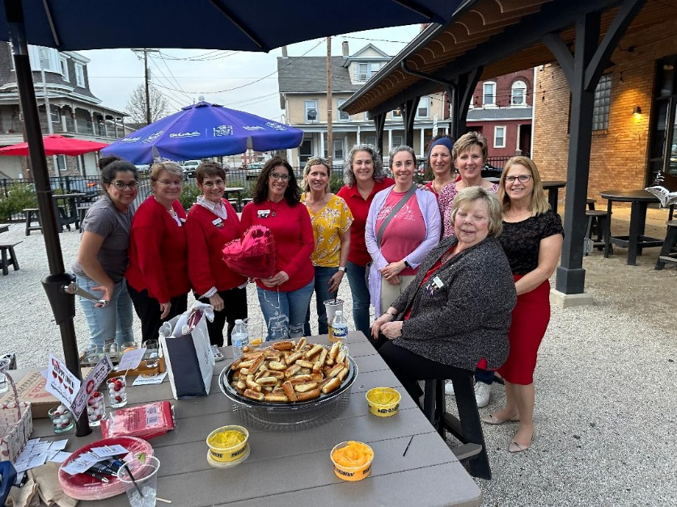

Group photo of members of Quakertown BPW who attended the first “Unhappy Hour” at the Trolley Barn on East Broad Street in town.

Weather cooperated for mid-March, and all had a great time. We also gained a new member to our club from this outing. Her name is Joan Brosnan.

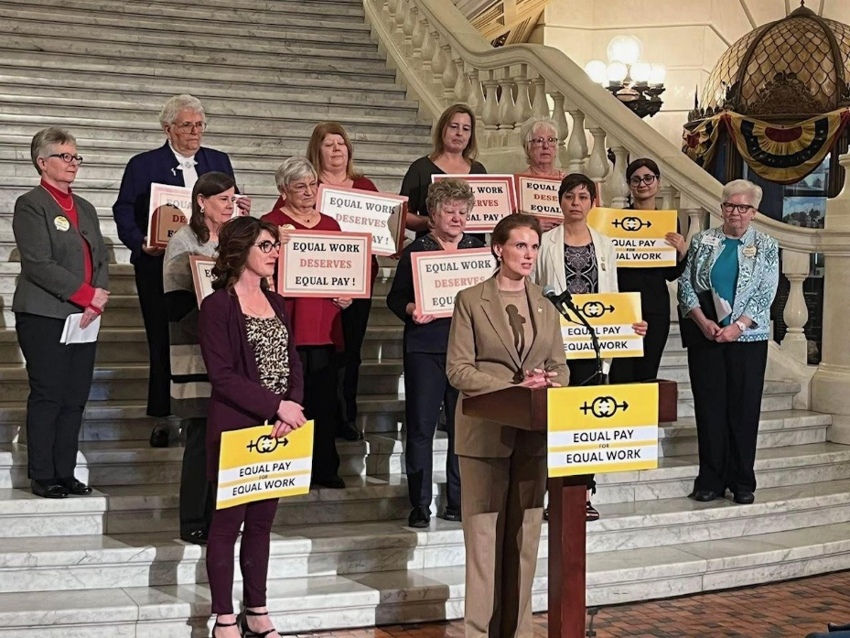

EQUAL PAY DAY

Here’s a photo of the gathering on the steps of the Capitol in Harrisburg for Equal Pay Day on March 26. Judy Guise from our club and Mary Weeks from Greater Conshohocken attended and are pictured top left in the photo.

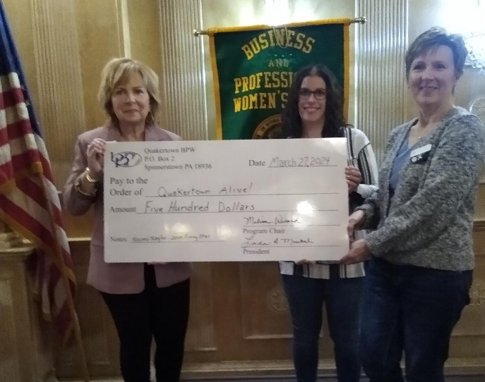
On March 14, Quakertown BPW held an Un-Happy Hour event at the Trolley Barn in town. Entries were submitted at that time to nominate a local professional who advocates for women and women-owned businesses. The winner of this event was Naomi Naylor from Quakertown Alive! She attended our March general meeting, speaking to us about Quakertown Alive and what she does to help the approximately 25 women-owned businesses in Quakertown. Pictured with Naomi at left are Treasurer, Crystal Smith and Co-President, Jeanne Schlicher donating a $500 check to Quakertown Alive! in Naomi’s honor.

NOMINATIONS COMMITTEE
The Nominating Committee of Toni Rubic, Chair, Linda Lokay and Gail Jancsics presented a slate of officers at our March meeting. They are the following: President—Melissa Wieand; Vice-President—Diane Sodano; Recording Secretaries—Rebecca Merola (Board minutes) and Jeanne Schlicher (General minutes); Treasurer—Crystal Smith. Secretary, Nancy, cast the ballot for all members since we technically had one candidate per office. The new officers will be installed for the 2024-2025 term at our annual picnic in June.

NEW MEMBERS
We are hoping to install two new members at our picnic in June: Stacy Ford and Joan Brosnan. Welcome Stacy and Joan! I believe that we now have a total of 7 new members.

ELEANOR KNOKE HOURS
Attached to this edition of the Quill is an Eleanor Knoke Hours form for you to fill out when you participate in BPW activities (but not our general meeting hours). If you fill out the form with your volunteer hours each month, they can be turned in to Linda Lokay at any meeting. She tallies them up and submits them in July. With enough hours, we may be able to keep our Eleanor Knoke award for another year!

DONATIONS TO FOOD PANTRY
This month we will be collecting instant coffee for the Quakertown Food Pantry. Please bring any donated items with you to the April meeting. Last month’s collection brought 29 loaves of sliced bread to the Food Pantry.

PADDLE RAFFLE SUNDAY, APRIL 28
If you have any donation items collected from area businesses, please get them to Melissa’s home by April 21st. Melissa and Crystal will have volunteer sign-up sheets to be passed out at the April meeting. Let’s make this Raffle our best yet!!

BPW/PA DISTRICT 11 GET TOGETHER TEA—APRIL 27
Ginny Bailey has arranged for our District 11 Tea at The Village Teahouse in West Point, PA
(Lansdale). Time is 12:15 p.m. Let Ginny know before April 13 if you would like to attend. Ginny’s email is muffygin@aol.com. Ginny is asking anyone who has not yet paid her to do so at the Teahouse. Cost is $43.

PA STATE CONVENTION
State Convention is planned for June 6-9 at the Best Western Premier in Harrisburg. It’ll be a fun-filled three days, and you learn lots about our organization. If you cannot attend the entire time, you can register to attend Friday or Saturday meeting and then drive home. The forms for registration and information are on our website bpwpa.wildapricot.org. in the Members Only section.

COMMUNITY YARD SALE SATURDAY MAY 4
We are participating in the Community Day yard sale at the home of Jeanne Schlicher, 2118 Barley Drive, Quakertown. Now is the time to go through your gently used items you’ve been wanting to part with and take them to Jeanne’s. Although the sale is advertised to run May 2, 3 and 4, Jeanne will only be doing this on the 4th. She will take donations after 4/22. You can drop on her front porch, or if you want to drop in person, she generally works from home on Monday and Friday. Text her to set a time for drop-off. She will need to know if you want your items back after the sale. If not, they will be donated. Jeanne also would like volunteers to help man the sale on the 4th. All proceeds from the sale will go to Quakertown BPW. More info to come at the April meeting.

CLUB HISTORY
Also attached to the email with this newsletter is a copy of our Club History for the past year. This was submitted to State Historian, Susan Bowery, for contest.

Here’s an amazing photo of the eclipse on Tuesday sent to me by Judy Guise of Elizabethtown, PA. The statue is of Freedom on top of the capitol in Harrisburg. I hope some of you got to see it, although it was pretty cloudy in Quakertown at that time.

April Birthdays
4/8 Christa Martin
4/9 Lyn Treffinger
4/11 Nancy Werner
4/19 Brandy Neifert
4/26 Jeanne Carcanague
4/30 Loretta Malloy
4/30 Linda Moskal

UPCOMING DATES TO REMEMBER
April 13 District 11 Spring Board Meeting in Montgomeryville
April 22 Earth Day!!
April 23 PA Primary Election
April 27 District 11 Tea at The Village Teahouse in West Point, PA
April 28 Paddle Raffle
May 1 Quakertown BPW Board Meeting
May 4 Community Day Yard Sale at Jeanne Schlicher’s
Souderton-Telford’s 7th Annual Locally Grown Showcase
June 6-9 BPW/PA State Convention

