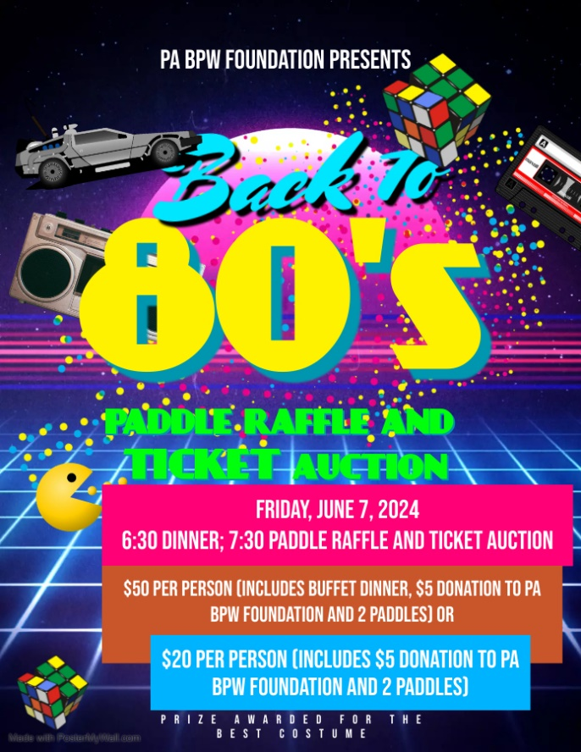

**BPW/PA State Convention**

**Friday, June 7, 2024**

**6:30 p.m. Dinner**

**7:30 p.m. Paddle Raffle and Ticket Auction**

**PADDLE RAFFLE**

**&**

**TICKET AUCTION**

The PA BPW Foundation fundraising committee is looking for donations for the Paddle Raffle and/or Ticket Auction to be held in conjunction with the Friday night fundraising event at State Convention.

 We are asking each District to donate an item for the Ticket Auction.

 We are also seeking donations from the districts, local organizations or individuals for the paddle raffle.

 If you are willing to donate an item, please compete the form below (one item per form) and send it to: Jean Ann Towle, PA BPW Foundation Fundraising Chair, 215 West Market Street, Pottsville PA 17901 or email the information to jat@pottsvillelibrary.org no later than May 24, 2024. Jean’s cell phone number is 570-778-2072.

 Name of Item:_____________________________________________________________________

 Item is for: __________ Ticket Auction ___________ Paddle Raffle _________ Either

 Item donated by: _________________________________________________________________

Name of person bringing item to convention: ____________________________________________

Cell phone number of person bringing item: _____________________________________________

District: ___________________________________________

Description of item:_________________________________________________________________

_________________________________________________________________________________

_________________________________________________________________________________

Value of item: $___________________________

**PLEASE BRING ITEM(S) TO STATE CONVENTION WITH YOU.**

**JEAN’S CELL PHONE #570-778-2072**